**Project Initialization and Planning Phase**

|  |  |
| --- | --- |
| **Date** | 11 July 2024 |
| **Team ID** | 739908 |
| **Project Name** | Smart Lender - Applicant Credibility Prediction For Loan Approval |
| **Maximum Marks** | 3 Marks |

**Problem Statement:**

Smart Lender, a financial institution, aims to automate the process of determining the credibility of loan applicants. The current process involves a manual assessment of applicant information, which is time-consuming and can lead to inconsistencies. To streamline this process and improve efficiency, Smart Lender wants to develop a machine learning model that can predict the credibility of an applicant based on various factors.



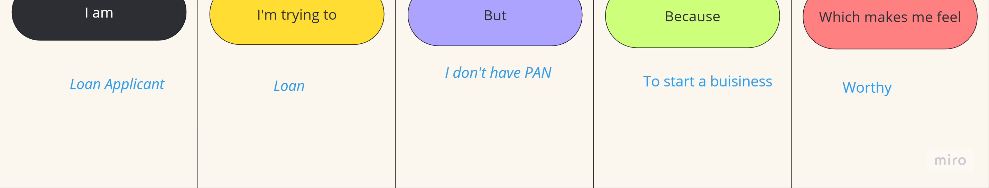



|  |  |  |  |  |  |
| --- | --- | --- | --- | --- | --- |
| **Problem**  **Statement**  **(PS)** | **I am**  **(Customer)** | **I’m trying to** | **But** | **Because** | **Which makes me feel** |
| PS-1 | Loan Applicant-I | Get Loan | I don’t have PAN. | To Start a  Buisiness. | Worthy |
| PS-2 | Loan Applicant-II | Study Loan | No property or Assests. | Further Studies | Relief &Gratitude |